## What is the significance of each trend?

**Remote Healthcare**: The significance of this trend is a very important one. Being able to access healthcare from virtually anywhere one is (home, at work or even on holiday) means that there is less need to travel long distances when in need of medical assistance in any form (Nuffield Department of Population Health, 2024). In addition, it reduces the strain and cost towards both the patients and the healthcare providers associated with in-person visits (Mammadov, 2023).

**Internet of Things (IoT)**: The Internet of Things (IoT) is significant for several reasons. Firstly, IoT connects various devices, enabling them to share data and communicate, leading to more efficient and automated systems (Lynn et al., 2020). In collecting and analyzing data from connected devices, IoT can provide valuable insights that can help in making informed decisions (Debnath & Chettri, 2021). Furthermore, IoT has the potential to boost economic growth by creating new business opportunities and improving productivity (Asad et al., 2022).

## How will each trend change the field of computer science?

**Remote Healthcare**: The vast amount of data that is collected from tele-medicine platforms makes it necessary that technologies like big data is used. The insights that can be derived from these large datasets can help to revolutionize healthcare and potentially provide recommendations on patient care (Kasoju et al., 2023). This could make healthcare more efficient and effective for patients and healthcare providers alike. The same can be said about the development of advanced algorithms, where artificial intelligence can also be incorporated into developing healthcare that works for both providers and patients (Chatterjee et al., 2023).

**Internet of Things (IoT)**: IoT devices will see that there is an exponential increase in data generation, necessitating advancements in data storage and analytics (Chataut et al., 2023). As more devices become interconnected, security and privacy of data will be more critical, thereby prompting advancements in data management, storage and analytics (Debnath & Chettri, 2021). Moreover, machine learning and artificial intelligence models have much to learn from the datasets that are generated from these IoT devices (Chataut et al., 2023).

## How will each trend change the experience of consumers, workers, or citizens?

**Remote Healthcare**: Increased accessibility means that patients have access to medical services from the comfort of their own homes, which is particularly beneficial for those who live in underserved or rural areas (Best, 2022). Reducing the need for travel can lead to early diagnosis and treatment. Furthermore, convenience and flexibility is another benefit, where patients need not take time off work or arrange childcare, for example, to get the medical care they require. This also means a work-life balance.

Remote healthcare also enhances public health by making it easier to monitor and manage chronic illnesses, conduct follow-ups and provide preventative care. It also bridges the gap in healthcare disparities by providing access to medical services for those who are marginalized or otherwise live in remote populations. (Best, 2022).

**Internet of Things (IoT)**: IoT devices like smart thermostats, lights and security systems are making homes more energy-efficient, convenient and secure. This means that consumers can control their home environments remotely, which ultimately provides them with more comfortable and safe homes to live in(Fearn, 2020). IoT devices can also enhance productivity by automating routine tasks and also providing real-time data for decision-making, leading to more informed and timely actions and improving overall job performance (Ajayi et al., 2023). Where citizens are involved, IoT can improve urban living through smart city initiatives. These include better traffic management, enhanced public infrastructure and energy efficiency (Khanna & Kaur, 2020). However, these integrations will also raise questions about data privacy and security.

## How will each trend fit in with your career interests or aspirations?

**Remote Healthcare**: As a father of two young children, remote healthcare stands out to me the most. My career in software engineering will no doubt be one that takes up a lot of time, so I want to be able to look after myself and my family without having to put my job at stake if anything were to happen to them. Being able to get in contact with doctors or other healthcare providers through remote methods means that I can get myself or them the help we need quickly, reducing the need to travel long distances or endure long waits (which are definitely not pleasant for young children).

**Internet of Things (IoT)**: Being able to control things remotely is helpful as a family man. When I’m at work, I can quickly switch on a camera to check in on my kids, perhaps even see where they are in the house, or even track them when they’re playing outside, enabling me to ensure their safety. I can also switch on the heater when we’re outside so that we can come home to a warm house, or even start the oven with dinner in it. IoT undoubtedly makes my life smoother, giving me time to take care of other needs.

## Which course outcomes have you achieved so far, and which ones remain?

At this point, I am confident in saying that I have accomplished all my course outcomes. The final outcome was accomplished in Enhancement 3, when I used apiKeyMiddleware to secure my database.

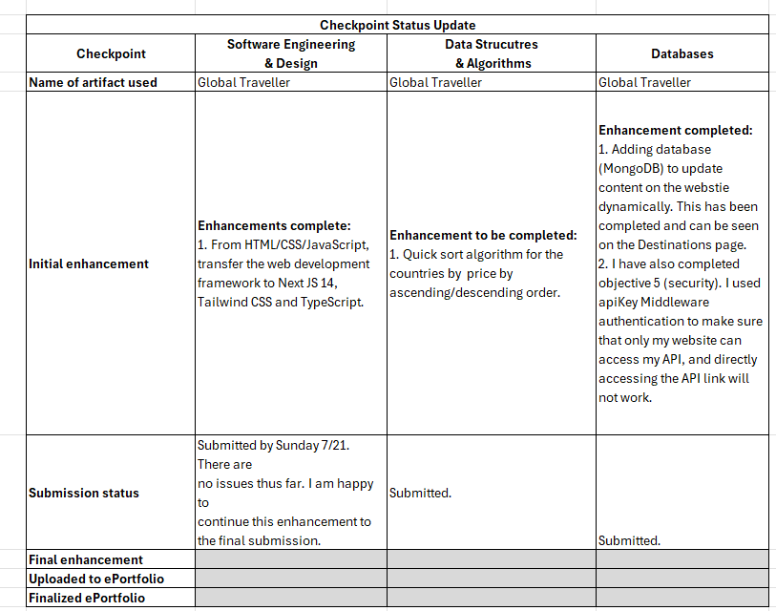

# References

Ajayi, S., Loureiro, S. M. C., & Langaro, D. (2023). Internet of things and consumer engagement on retail: state-of-the-art and future directions. EuroMed Journal of Business, 18(3), 397–423. https://doi.org/10.1108/EMJB-10-2021-0164

Asad, M. M., Naz, A., Shaikh, A., Alrizq, M., Akram, M., & Alghamdi, A. (2022). Investigating the impact of IoT-Based smart laboratories on students’ academic performance in higher education. Universal Access in the Information Society. https://doi.org/10.1007/s10209-022-00944-1

Best, J. (2022). Remote working in medicine: the good, the bad, and the barriers. BMJ, o2127. https://doi.org/10.1136/bmj.o2127

Chataut, R., Phoummalayvane, A., & Akl, R. (2023). Unleashing the Power of IoT: A Comprehensive Review of IoT Applications and Future Prospects in Healthcare, Agriculture, Smart Homes, Smart Cities, and Industry 4.0. Sensors, 23(16), 7194. https://doi.org/10.3390/s23167194

Chatterjee, A., Prinz, A., Riegler, M. A., & Das, J. (2023). A systematic review and knowledge mapping on ICT-based remote and automatic COVID-19 patient monitoring and care. BMC Health Services Research, 23(1), 1047. https://doi.org/10.1186/s12913-023-10047-z

Debnath, D., & Chettri, S. Kr. (2021). Internet of Things: Current Research, Challenges, Trends and Applications (pp. 679–694). https://doi.org/10.1007/978-981-33-4604-8_52

Fearn, N. (2020). How the Internet of Things can transform customer experiences. https://www.itpro.com/strategy/28543/how-the-internet-of-things-can-transform-customer-experiences

Kasoju, N., Remya, N. S., Sasi, R., Sujesh, S., Soman, B., Kesavadas, C., Muraleedharan, C. V., Varma, P. R. H., & Behari, S. (2023). Digital health: trends, opportunities and challenges in medical devices, pharma and bio-technology. CSI Transactions on ICT, 11(1), 11–30. https://doi.org/10.1007/s40012-023-00380-3

Khanna, A., & Kaur, S. (2020). Internet of Things (IoT), Applications and Challenges: A Comprehensive Review. Wireless Personal Communications, 114(2), 1687–1762. https://doi.org/10.1007/s11277-020-07446-4

Lynn, T., Endo, P. T., Ribeiro, A. M. N. C., Barbosa, G. B. N., & Rosati, P. (2020). The Internet of Things: Definitions, Key Concepts, and Reference Architectures (pp. 1–22). https://doi.org/10.1007/978-3-030-41110-7_1

Mammadov, E. (2023). The Importance of Computer Science in Healthcare. CS Careerline.

Nuffield Department of Population Health. (2024). The role of remote technologies in healthcare.